PARTNERSHIPS MANUAL
2022/2023

Academic Registry
Title: Partnerships Manual
Version | Issue Date | Revision Description | Author | Approved By & Date | Next Review Date
1.0 | Sept. 2019 | First Issue | Hayley Burns | Academic Board and Quality Assurance Committee  Sept. 2019 | May 2020
2.0 | Sep. 2020 | Second Issue | Nicola Poole | Quality Assurance Committee  Sept. 2020 | May 2021
3.0 | Sept. 2021 | Revision | Nicola Poole | Partnerships Quality Sub-Committee  Sept. 2021 | May 2022
4.0 | Apr. 2022 | Revision | Hayley Burns | Quality Assurance Committee  Apr. 2022 | May 2022
5.0 | Aug 2022 | Revision | Claire Morgan | PQSC  September 2022 | May 2023
6.0 | Nov 2022 | Revision | Claire Morgan | Quality & Academic Services  November 2022 | May 2023

Contents
1. INTRODUCTION 4
1.1 Scope of Procedures 4
1.2 External and internal reference points 4
1.3 Definitions / models of partnership provision 4
1.4 Responsibilities for partnership provision 7
1.5 Committees and groups 10
1.6 The Partnership Register 13
2. APPROVAL OF NEW PARTNERS 13
2.1 Risk management and partnership 13
2.2 Criteria for new partnerships 14
2.3 Initial enquiries on the development of a new partnership 14
2.4 Due diligence overview 14
2.5 Two stage model of partnership approval 17
2.6 Strategic Approval 21
2.7 Consideration and sign-off of the proposal 25
2.8 Full approval of a new partnership 25
2.9 Full approval events: Location 25
2.10 Full approval events – responsibilities 26
2.11 Full approval – documentation requirements 27
2.12 Full Approval Panels 27
2.13 Full Approval event agendas 28
2.14 Full Approval outcomes 29
2.15 The Partnership Contract 30
2.16 Enrolment 33
2.17 Partnership Management Handbook 33
2.18 Recognised Teacher Status 33
2.19 Course validation requirements 34
3. AMENDING ARRANGEMENTS WITH AN EXISTING PARTNER 35
3.1 Types of amendments 35
3.2 Approval processes for amending partnership arrangements 35
3.3 Amendments to contracts 37
4. QUALITY ASSURANCE FOR PARTNERS 37
4.1 University quality assurance processes for partnerships 37
4.2 Continuous Monitoring 37
4.3 External Examiners 38
5. ANNUAL BUSINESS REVIEW OF PARTNERSHIPS 38
5.1 Rationale 38
5.2 Process 39
6. PARTNER REVIEW AND RE-APPROVAL 40
6.1 Purpose 40
6.2 The process 41
6.3 Documentary evidence 42
6.4 The PRR event 43
6.5 PRR Outcomes 43
7. CLOSING A PARTNERSHIP 44
7.1 Reasons for closure 44
7.2 Approval to close a partnership 44
7.3 End of Approval Period 45
7.4 Closure and the contract 46
8. PARTNERSHIP AND LIAISON MANAGEMENT 47
8.1 Partnership Managers, University Link Officers and Partner Link Officers 47

INTRODUCTION

Scope of Procedures

    - The Partnerships Manual sets out the definitions, processes and policies for the operation of the University’s provision with others. It covers all arrangements where the University works in partnership with other organisations to design and/or deliver courses and/or to award qualifications. It should be read in conjunction with the Quality Manual which sets out the University’s overarching approach to its quality framework. Where applicable, contextualised guidance documents are provided within this manual.

    - The Partnerships Manual provides guidance on:

- Definitions and models of partnership provision
- Approval of new partners
- Amending arrangements with an existing partner
- Ongoing quality assurance processes for partnership arrangements
- Annual Business Review of partnerships
- Partner Review and Re-approval
- Closure of a partnership
- Partnership and liaison management

External and internal reference points

    - These procedures are designed to ensure the University meets its responsibilities to uphold fundamental principles that apply to higher education quality across the UK. They have been designed to align with the revised QAA Quality Code for Higher Education (Nov 2018) and specifically with Advice and Guidance: Partnerships.

    - The procedures also reflect the principles central to the University’s Quality Framework (see section 1.3 and the Quality Manual).

    - It is expected that the University’s partnerships align with its mission and strategic drivers and Internationalisation 2030 strategy.

Definitions / models of partnership provision

    - Standard requirements for partnership provision

It is an expectation that:

- All University courses delivered through a partnership arrangement will be subject to the University’s academic regulations and quality assurance procedures.
- Each partnership arrangement is underpinned by, as appropriate, an agreement or contract signed by the parties involved. The agreement or contract will outline the roles and responsibilities of the University and the partner.
- Partners are approved for the delivery of University courses at approved locations. They are not permitted to deliver University courses through other organisations unless that is specifically allowed by the contract
- No partnership activity will be permitted to commence until the agreement/contract has been signed by both parties and received by Quality.
- The language of delivery will always be English or Welsh.

    - Definitions

Partnership: any arrangement in which the University makes an award or gives credit towards an award on the basis of education provided by, with or at another organisation in the UK or overseas.

Transnational Education (TNE): the delivery of higher education level awards by recognised UK degree-awarding bodies in a country, or to students, other than where the awarding provider is based.

The University has a number of distinct formal partnership arrangements as follows:

Type of Partnership | Definition
Pathway College | Delivery and assessment of courses by a partner organisation at one or more of the University campuses, under the delegated authority of the University and validated by the University. The development and design of such courses may be by the partner organisation or through co-creation in partnership with the University.
Validated | Development and delivery by a partner organisation of courses which the University has judged and approved to be of an appropriate standard and quality to contribute, or lead, to a University award.
Full Franchise | Delivery by another organisation, under the delegated authority of the University, of courses designed and validated by the University leading to a single award. This form of partnership is delivered only in the UK, unless Executive approval is granted.
Joint Franchise | Partial delivery and assessment by another organisation under the delegated authority of the University, of any courses designed and validated by the University leading to a single award. The details of delivery and assessment will be determined at validation and specified within the partnership contract.
Direct Delivery | A course designed and validated by the University delivered by University staff at a host organisation. The University retains full responsibility for the delivery and the award of the qualification. The partner organisation may be involved in supporting delivery, for example with respect to student support and management of assessment processes. The form of partnership approval will be calibrated to the scope of the partner’s support of delivery.
Advanced Standing | Entry is guaranteed for students from a partner to specified courses covered by an Advanced Standing Agreement, leading to a single award by the University. The advanced entry can be applied at any level but must be explicitly stated in each case. The Regulations for Taught Courses defines credit limits.
Advanced Standing with additional (Joint) provision  (e.g., Chinese MoE) | An arrangement whereby students who satisfy academic criteria and successfully complete an approved programme of study in a partner institution are automatically entitled (on academic grounds) to be admitted with advanced standing to a subsequent part or year of an USW degree course.  As part of the approved course of study at the partner institution, the University may have to contribute a proportion of the teaching course/curriculum at the partner institution (usually on grounds of maintaining standards throughout the course).
Apprenticeships | The University works in partnership with an employer to facilitate the delivery of the chosen apprenticeship through both academic learning and workplace learning, offering a degree qualification upon successful completion of the apprenticeship.
Locations of Delivery | The University is only using a location to deliver content for a short, finite period. Full partnership approval is not necessary, but a Site Visit Report is required.
International Student Exchange | Formal reciprocal arrangements through which students from an overseas higher education institution may come to the University to study on a specified course for a specified period of time and University students study at the overseas institution on the same basis.
Table 1: Partnership Definitions

In addition to the formal partnership arrangements defined above, the University has several agreements in place for the purpose of expanding recruitment streams and developing collaborative provision. These are outlined below:

Type of arrangement | Definition
Admissions Agreement | These are used for recruitment purposes and confirm that the University will consider applications, on an individual basis, from students from a specified institution, provided they meet the entry requirements. They may make reference to admission via Recognised Prior Learning (RPL).
Memorandum of Understanding | These are used to facilitate discussions around the development of a partnership arrangement and/or strategic alliance. These are typically a precursor to a legally binding Institutional Agreement and/or Memorandum of Cooperation.
Table 2: Other Agreement Types

1.4 Responsibilities for partnership provision

1.4.1 The Quality and Partnerships (QAP) Team

For all partnerships, QAP provides advice and guidance on all aspects of approving and managing partner provision, including:

- Approval, re-approval and closure of partnership arrangements
- Validation and re-validation of courses associated with partnerships
- Continuous Monitoring procedures
- The type of partnerships and changes to the type of an approved partnership
- Selection, appointment and reporting requirements for External Examiners
- The University’s Recognised Teacher Status (RTS) Scheme by which all staff at partners delivering on University approved courses become recognised teachers
- Partnership liaison arrangements, including the University Link Officer role (or equivalent) and its responsibilities

1.4.2 In addition, QAP has operational responsibilities for partnership arrangements, including:

- Management and processing partnership arrangements
- Maintaining an overview of contractual arrangements for all partnership activity outlined in this manual
- Supporting the Partnership Quality Sub-Committee (PQSC), and the Partner Operational Group.
- Members of the Portfolio Oversight Group (POG), and the POG sub-groups for international and UK activity (International Partnerships Oversight Sub-Group and UK Partnerships Oversight Sub-Group)
- Facilitating production of the templates for Continuous Monitoring reports for partners.
- Facilitating the production and exchange of performance data and other related information for partners
- Maintaining the University’s partnership register of all approved partnerships (see section 1.6) by Faculty Quality Assurance Committees (FQAC), PQSC and the University’s Quality Assurance Committee (QAC).

1.4.3 Key roles and responsibilities for partnership activity are as follows.

Tier | Gatekeeper | Activity | Gateway
Gateway 5: University | Vice Chancellor | Executive responsibility for academic development and quality, including partnership provision.  Ultimate responsibility for partnership approval following recommendations from Quality Assurance Committee (QAC). | Academic Board
 | Deputy Vice Chancellor | Scrutiny and sign off of the financial and legal due diligence processes for partnership proposals and of fit with the University’s strategic plans.  The DVC is supported by members of the University Executive, Deans and Directors/Heads of Corporate Services. | University Executive / Portfolio Oversight Group (POG)
 |  | Responsibility for quality assurance and enhancement in relation to all partnership provision from approval to closure. | QAC
 | Head of International and Partnership Development | Advises the Executive / POG on strategic approval of proposals for partnerships with overseas organisations. | POG / International Partnerships Oversight Sub-Group
 | Director of FE Partnerships and Degree Apprenticeships | Advises the Executive / POG on strategic approval of partnership developments with UK organisations. | POG / UK Partnerships Oversight Sub-Group
 | Head of Quality and Academic Services (QAS) QAS | Oversight of quality assurance and enhancement in relation to all partnership provision from approval to closure of a partnership. | Partnership Quality Sub-Committee (PQSC)
 | Partnership Manager | Single point of day-to-day contact for partnerships involving more than one faculty. | PQSC
 | Commercial and Client Services Office (CCSO) | Where applicable, the conduit between faculties and partners with regard to administration of the operational functions of delivery via partnerships | N/A
 | Future Students | Audits and approves partner marketing and publicity information. | PQSC
 | Academic Registry: Quality and Academic Services | Administers the records for students studying at partner organisations; issues certificates etc. | Assessment Boards
 | Student Support and Library Services | Provides online student support and access to learning resources. | Re/Validation Panels
Gateway 4: Faculty/ College | Dean | Considers potential partner developments and proposes to one of the POG Sub-groups (International or UK). | Faculty Executive Committee (or equivalent)
 |  | Oversees academic standards, quality assurance and enhancement at the faculty level, assisted by members of the Faculty Executive. | Faculty Quality Assurance Committee (FQAC)
 | Faculty Quality and Academic Services Manager (QASM) in liaison with the Quality and Partnerships Manager | All aspects of quality assurance and associated administration relating to partnership provision, including formal agreements/contracts for their faculty. | FQAC
Gateway 3:  School / Subject | Head of Subject (or equivalent) | Overall responsibility for the management of partnerships within the school.  Approval of Recognised Teacher Status (RTS) submissions. | Executive Team (or equivalent)
Gateway 2: Course | University Link Officer (ULO) | The University’s link person with the partner(s); the ULO oversees the operation of the partnership at course level in conjunction with the Partner’s Link Officer (PLO), the member of staff at the partner with operational responsibilities.  Further information on the roles of the ULO and PLO are set out in section 8 on partnership liaison. | PQSC / QAC
 | Course Leader | The Course Leader oversees academic standards, quality assurance and enhancement, assisted by their counterparts in the partnership organisation and Module Leaders. | Continuous Monitoring
Gateway 1: Module | Module Leader | The Module Leader oversees academic standards, quality assurance and enhancement assisted by their counterparts in the partner organisation.
Table 3: Key Roles and Responsibilities for Partnerships

1.5 Committees and groups

The following committees and groups are involved in the approval, management and closure of partnerships in the following ways:

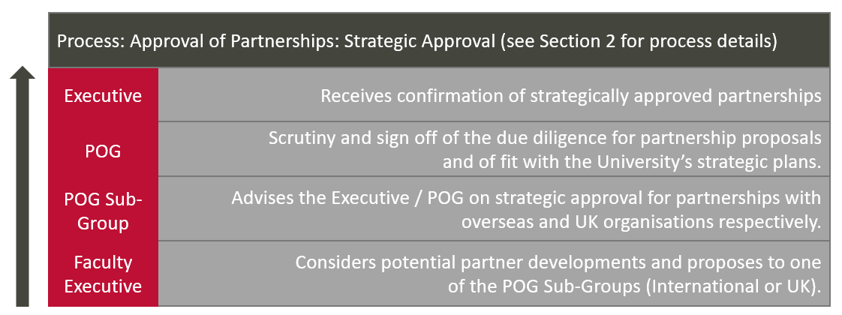
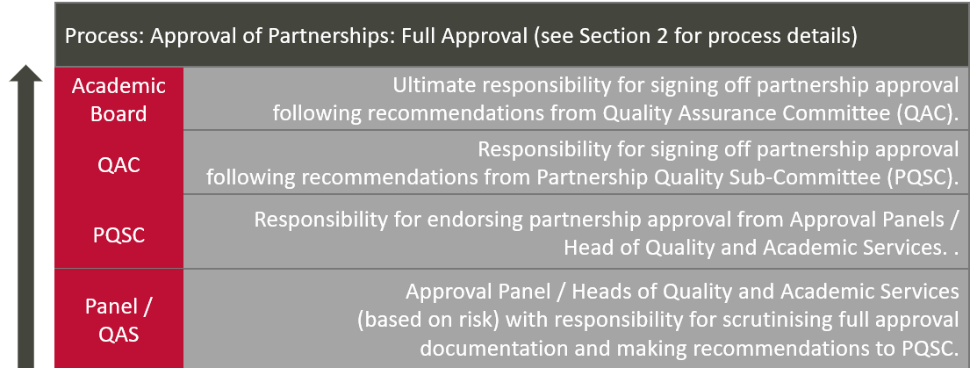

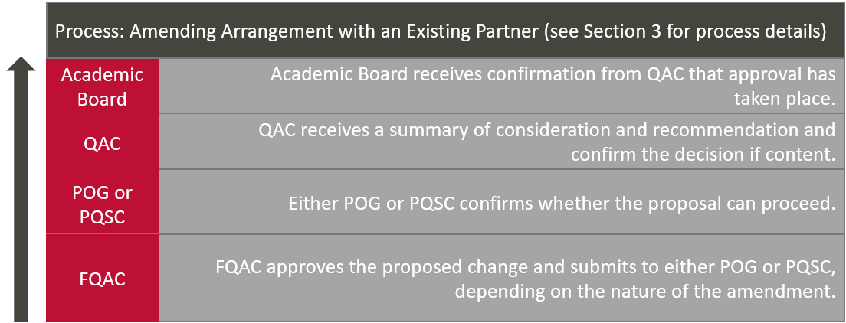

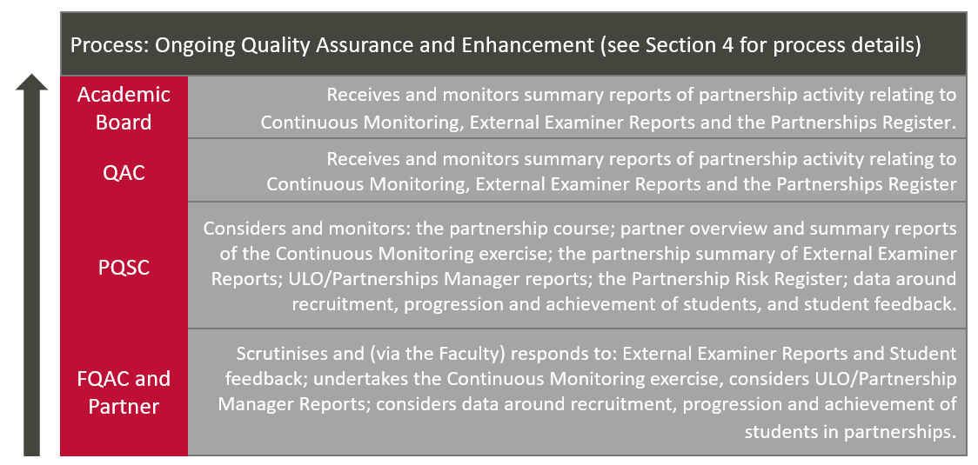

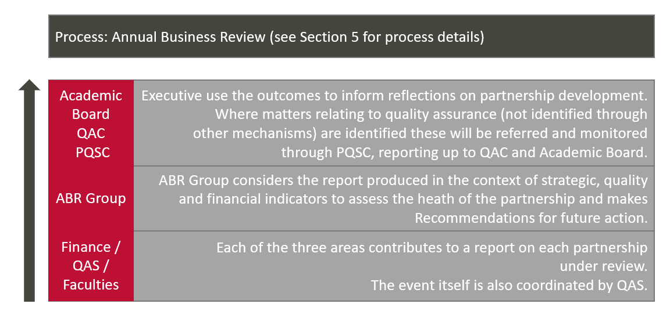

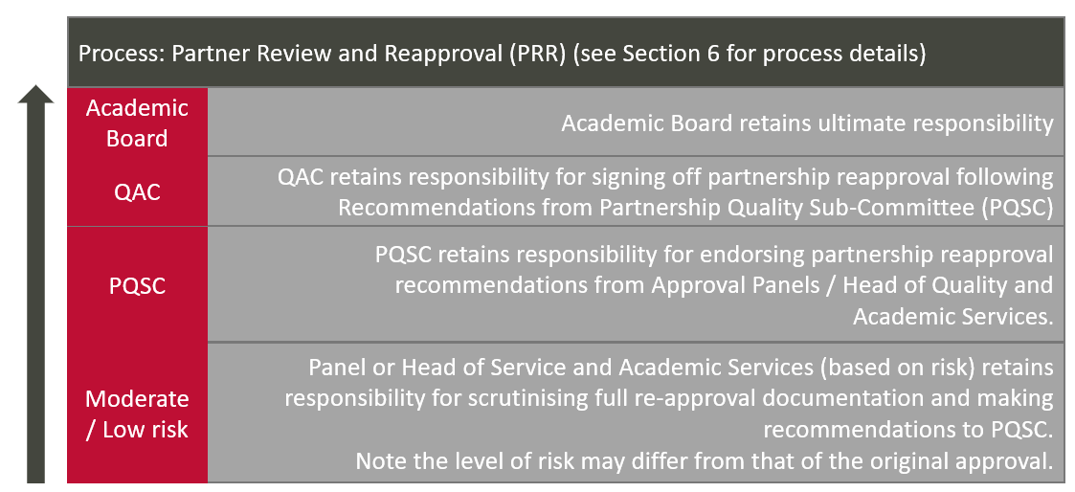

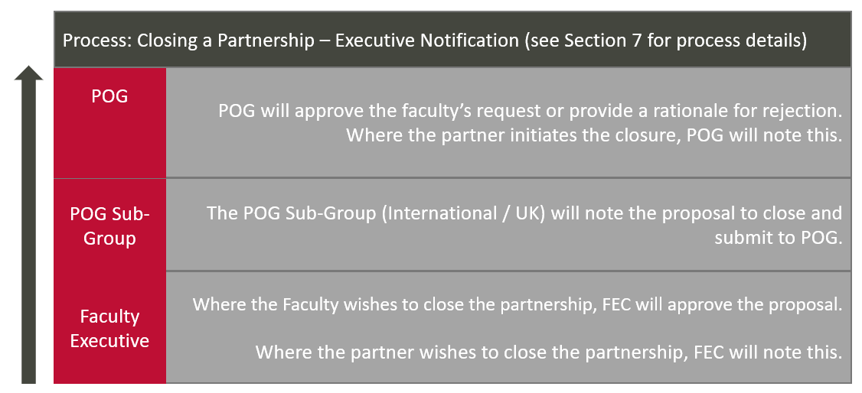

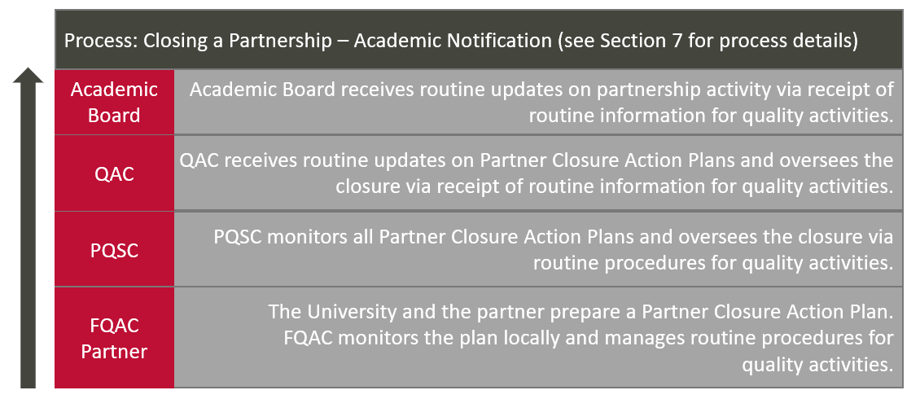

1.6 The Partnership Register

1.6.1 The University has a Partnership Register, maintained by QAP, which lists of all its partnership arrangements which are subject to a formal agreement. The Register is updated to record any changes following review or evaluation of the partnership or other relevant changes, such as change of University Link Officers (ULO) / Partner Link Officers (PLO).

2. APPROVAL OF NEW PARTNERS

2.1 Risk management and partnership

2.1.1 The University observes the fundamental principle underpinning all partnership provision, that it has ultimate responsibility for academic standards and the quality of learning opportunities, regardless of where these opportunities are delivered and who provides them. It also acknowledges that delivering learning opportunities with others inevitably carries risks in terms of academic standards and the quality of the student learning experience, the University’s standing and reputation, and the level of human, financial and legal costs.

2.1.2 However, in its approach to developing and approving partnerships, the University recognises that different models of partnership have inherently higher and lower risks attached. These are indicatively classified in Table 4 which sets out models of partnership and likely risk levels.

2.1.3 At the same time, the University has a flexible risk-informed approach which, while ensuring that approval procedures reflect the status and scope of the type of partnership, tailors approval to the specifics of the prospective partner and the partnership. Thus, the arrangements for approval may depend on the potential partner’s historic performance, the University’s experience in a particular type of partnership, the nature of the proposed activity, and the risk applicable to the model of partnership. In line with this approach to the management of risk, and an acknowledgement that proposals will not always fit neatly into any particular category, the processes in this section are designed to be applied flexibly.
2.1.4 Partnerships may operate across a number of the different partnership models outlined in section 1, as well as across faculties, schools and courses. To that end, University oversight of partnerships is centrally maintained by QAP who are able to offer consistent, comprehensive and risk-based guidance on approval processes. This also allows the University to share information across faculties and professional services to enable the most appropriate form of enquiry for a new partner or any provision delivered in partnership.

2.2 Criteria for new partnerships

2.2.1 Whilst each proposal is considered on its merits, the University expects each proposed partnership to meet the following criteria:

- It should clearly align with the University’s strategic direction and aims.
- There should be clear evidence of the legal, financial, academic and reputational risks attaching to the proposed partnership and evidence of how any risks will be mitigated.
- For international partnerships, the country’s prevailing social, political and ethical context should align with the University’s mission.

2.3 Initial enquiries on the development of a new partnership

2.3.1 Proposals for new partnerships may come from a number of sources, including approaches from external organisations and opportunities identified from within the University. Therefore, the initial point of contact within the University could include Executive, a faculty, the Head of International and Partnership Development, the Director of FE Partnerships and Degree Apprenticeships, and QAP.

2.3.2 At an early stage, the relevant staff member, assigned by the faculty/department leading on the proposal, should engage in informal discussions to develop mutual understanding of the potential partnership and to gain further understanding of the partner. Faculties will be expected to take ‘in principle’ decisions to consider a potential partnership, prior to the development of formal documentation. At the same time, the assigned lead should informally engage with the Head of Quality and Academic Services (or nominee) to confirm the credibility and reputation of the potential partner, and to confirm that the prospective partner has the minimum requirements for partnership with the University.

2.4 Due diligence overview

2.4.1 Amongst its ‘guiding principles’, the Quality Code, Advice and Guidance: Partnerships (2018) states that:

- The awarding organisation will have in place appropriate governance to authorise and oversee the development … of partnership arrangements (Guiding Principle); and
- The awarding organisation … should conduct a range of due diligence enquiries appropriate to the type of partnership, the detailed arrangements and the identified level of risk (Guiding Principle 3)

2.4.2 While Chapter B10 of the previous Quality Code, ‘Managing Higher Education Provision with Others (2012) has been superseded by the revised Code mentioned above, it offered sound advice on ‘Key areas where proportionate due diligence enquiries are necessary for most arrangements.’ These include:

- The ability of the prospective … partner to provide the human and material resources to operate the arrangement successfully.
- The academic/professional capacity of the prospective … partner organisation to deliver any learning and teaching or support at the appropriate levels.
- The ability of the prospective … partner organisation to provide an appropriate and safe working environment for students.
- The legal status of the prospective … partner organisation in its own country and its capacity to enter into a legally binding agreement.
- The accredited or recognised status of a prospective partner organisation accorded by the relevant authorising bodies in the country where the provision will be delivered.
- The reputation and/or academic standing of the organisation (drawing on a range of … indicators, as well as the experience of other providers who have collaborated with the organisation).
- The financial stability of the prospective partner.

2.4.3 The University conducts due diligence as part of the strategic approval process for new proposed formal partnerships; this is captured in the Partner Proposal Form. The form requires financial, legal and academic due diligence.

2.4.4 While the University requires comprehensive due diligence on any new partner, the scope of due diligence will vary dependent on the risk attached to the proposed partner. For example, an international proposal generally carries greater risk than a partnership with a local further education college. General risk categories are listed below in Table 4.

2.4.5 Due diligence is formally refreshed at the point of partner re-approval (see section 6).

2.4.6 Table 4 provides the list of partnership types with an indicative category of risk, and an estimation of the scope of due diligence. However, as noted, the potential risk and the due diligence required to help mitigate the risk will depend on the specifics of the partnership. This will be determined in consultation with the Head of Quality and Academic Services (or nominee).

Type of Partnership | Partnership Location | Indicative Risk  Level | Due Diligence implications
Pathway College | UK | Moderate | - Financial, legal and academic required
 | Overseas | High
Validated | Home | Moderate | - Financial, legal and academic required
 | Overseas | High
Full Franchise | UK | Moderate | - Financial, legal and academic required
 | Overseas
Joint Franchise | UK | Moderate | - Financial, legal and academic required
 | Overseas
Direct Delivery | UK and overseas | Moderate | - Financial and legal required  - Academic should consider facilities for delivering and supporting learning and teaching
Advanced Standing | UK and overseas | Moderate | - Financial, legal required  - Academic should consider partner experience of delivering relevant curriculum
Advanced Standing with additional (Joint) provision (e.g., Chinese MoE) | UK and overseas | Moderate | - Financial, Legal required  - Academic should consider partner experience of delivering relevant curriculum
Locations of Delivery | UK and overseas | Low | - Site Visit Report for new partners
International Student Exchange | N/A | Low | - Academic required
Table 4: Partnership Types with Indicative Risk Ratings

In addition to the due diligence required by the strategic approval process for formal partnerships as defined in section 1, due diligence is also required for less formal agreements with new institutions as detailed below.

Type of arrangement | Partnership Location | Indicative Level of Risk | Due Diligence Implications
Admissions Agreement | UK and overseas | Low | - Informal scrutiny of institution
Memorandum of Understanding | UK and overseas | Low | - Informal scrutiny of institution
Table 5: Other Partnership Types

2.5 Two stage model of partnership approval

2.5.1 In line with the UK Quality Code, Advice and Guidance: Partnerships, Guiding Principle, 2, the University’s partnership approval process has two stages:

- Strategic approval
- Full approval

2.5.1 Strategic approval is granted on the basis of a due diligence exercise on the proposed partner. The proposal, once agreed by the Faculty Executive (or equivalent), is submitted to one of the two sub-groups of POG (International or UK), based on its geographical location, and a recommendation is made to POG. POG decides whether the University should continue with the proposal to establish a partnership with the organisation in question (see section 2.8).

2.5.2 Full approval is subsequently undertaken, the format of which will vary according to the risk accruing. Processes for full approval are set out in sections 2.9 to 2.14.

2.5.3 The following diagrams outline the two-stage approval process for formal partnerships. Note that course approval is a separate process, carried out in accordance with the process outlined in the Quality Manual. Course approval for a partnership cannot take place before the partner has been approved, although approval events can be held concurrently, provided partnership approval is agreed first.

2.5.3.1. Partnership Approval Process: Pathway College, Full Franchise, Joint Franchise, and Direct Delivery
Business and Academic Due Diligence
(Form sections: Outline Proposal, Market & Resources, Business Case, Academic)
Sign off by Dean of Faculty (or nominee)
Legal Due Diligence
(Form sections: Legal Due Diligence)
Sign off by University Secretary and/or the University Solicitor
Financial Due Diligence
(Form sections: Financial Due Diligence)
Sign off by Finance Department

STRATEGIC APPROVAL
Submitted on New Partner Proposal Form through Faculty Executive, one of the POG Sub-groups and approved by POG

Major Concerns Identified
(High risk)
Proceed with Caution
(Moderate risk)
No Concerns Identified
(Low risk)

PROPOSED PARTNERSHIP WILL NOT PROCEED

RISK RATING CONFIRMED FOR FULL APPROVAL
QAP to determine approval process based on level of risk

FULL APPROVAL PROCESS BEGINS
Partnership and Course

Indicative Documentation for Course Approval:
- Addendum to Validation Document or Validation Document
- RTS Forms for staff delivering course/modules
- Course and Module Specifications
- Partner curriculum documents

Indicative Documentation for Partnership Approval:
- Partnership Management Handbook
- Site Visit Report
- Supporting documents about the Partner

APPROVAL NOT GRANTED
APPROVAL EVENT / ACTIVITY HELD
Based on moderate or low risk, either an event or a formal sign off will take place, depending on the nature of the proposal

CONDITIONS OF APPROVAL COMPLETED

SUBMISSION TO PQSC AND THEN QAC FOR APPROVAL

INSTITUTIONAL AGREEMENT AND MEMORANDUM OF CO-OPERATION CONTRACTS SIGNED BY RELEVANT PARTIES

2.5.3.2. Partnership Approval Process: Advanced Standing
Business and Academic Due Diligence
(Form sections: Outline Proposal, Market & Resources, Business Case, Academic)
Sign off by Dean of Faculty or nominee
Legal Due Diligence
(Form sections: Legal Due Diligence)
Sign off by University Secretary and/or the University Solicitor
Financial Due Diligence
(Form sections: Financial Due Diligence)
Sign off by Finance Department

STRATEGIC APPROVAL
Submitted on New Partner Proposal Form through Faculty Executive, one of the POG Sub-groups and approved by POG

Major Concerns Identified
(High risk)
Proceed with Caution
(Moderate risk)
No Concerns Identified
(Low risk)

PROPOSED PARTNERSHIP WILL NOT PROCEED

RISK RATING CONFIRMED FOR FULL APPROVAL
QAP to determine approval process based on level of risk

FULL APPROVAL PROCESS BEGINS
Partnership only

Indicative Documentation for Partnership Approval:
- Articulation Credit Mapping Form
- University Course and Module Specifications
- Partner Course and Module Specifications
- Supporting documents about the Partner

APPROVAL NOT GRANTED
APPROVAL EVENT / ACTIVITY HELD
Based on moderate or low risk, either an event or a formal sign off will take place, depending on the nature of the proposal

CONDITIONS OF APPROVAL COMPLETED

SUBMISSION TO PQSC AND THEN QAC FOR APPROVAL

INSTITUTIONAL AGREEMENT AND ARTICULATION MEMORANDUM OF CO-OPERATION CONTRACTS SIGNED BY RELEVANT PARTIES

2.5.3.3. Partnership Approval Process: International Student Exchange Agreements

Business and Academic Due Diligence
(Form sections: Outline Proposal, Market & Resources, Business Case, Academic)
Sign off by Dean of Faculty or nominee

STRATEGIC APPROVAL
Submitted on New Partner Proposal Form through Faculty Executive, one of the POG Sub-groups and approved by POG

Major Concerns Identified
(High risk)
Proceed with Caution
(Moderate risk)
No Concerns Identified
(Low risk)

PROPOSED PARTNERSHIP WILL NOT PROCEED

RISK RATING CONFIRMED FOR FULL APPROVAL
QAP to determine approval process based on level of risk

FULL APPROVAL PROCESS BEGINS
Partnership only

Indicative Documentation for Partnership Approval:
- Proforma for Application for Approval of an International Student Exchange
- Business Case
- Site Visit Report
- Statement for Student Support, Wellbeing and Monitoring
- University and Partner Course and Module Specifications
- Supporting documents about the Partner

APPROVAL NOT GRANTED
APPROVAL EVENT / ACTIVITY HELD
Based on moderate or low risk, either an event or formal sign off will take place, depending on the nature of the proposal

CONDITIONS OF APPROVAL COMPLETED

SUBMISSION TO PQSC AND THEN QAC FOR APPROVAL

INSTITUTIONAL STUDENT EXCHANGE MEMORANDUM OF AGREEMENT SIGNED BY RELEVANT PARTIES

2.6 Strategic Approval

Table 6 below lists all the relevant forms for each process with the associated risk, level of approval and responsibilities for completion of the forms. Instructions for completing each individual form can be found within the forms themselves. Any forms that require completion by the proposed partner are the responsibility of the Faculty Lead to arrange.

Arrangement Information |  | Strategic Approval (Stage 1)
Partnerships Type | Level of Risk | Forms to be completed | Gateway approval
Location of Delivery | Low | Site Visit Report | FEC
International Student Exchange | Low | Partner Proposal Form | FEC  POG Sub-Group  POG
Pathway College | Moderate (UK)  High (Overseas) | Partner Proposal Form | FEC  POG Sub-Group  POG
Validated Provision | Moderate | Partner Proposal Form | FEC  POG Sub-Group  POG
Full & Joint Franchise | Moderate | Partner Proposal Form | FEC  POG Sub-Group  POG
Direct Delivery | Moderate | Partner Proposal Form | FEC  POG Sub-Group  POG
Advanced Standing | Moderate | Partner Proposal Form | FEC  POG Sub-Group  POG

Table 6: Partnership Template Grid

2.6.1 Partner Proposal Form

The application for Strategic Approval requires completion of the Partner Proposal Form, which is normally completed by the identified faculty contact from the proposing faculty. This applies to all formal partnerships, as defined in section 1.

In every case, and prior to starting work on the documentation, the assigned lead should discuss the proposal with the Quality and Partnerships Manager or their Faculty Quality and Academic Services Manager (QASM) as, in the context of risk-based development and approval of partnerships, requirements for strategic approval will vary depending on issues such as the:

- potential partner’s historic performance
- University’s experience for that type of partnership
- intrinsic risk applicable to the model of partnership

2.6.2 The Partner Proposal Form requirements are set out in Table 7 below:

Part | Content | Scope | Sources of advice | Scrutiny to confirm | Sign off by
1 | Outline Proposal | - Description of nature of proposed partnership and potential courses  - Key information about proposed partner  - Strategic fit of proposed partnership | - Quality and Academic Services  - Deputy Vice Chancellor / Director of USW International / Director of FE (for advice on strategic fit of proposed partnership) | - Proposal fits with University and faculty strategies;  - Faculty, and where relevant, University, can provide sufficient resources to support partnership  - Proposal fits with existing academic expertise | - Dean of Faculty  - Deputy Vice Chancellor (for University level proposals)
2 | Academic Due Diligence | - Proposed partner’s status as an HE provider/partner  - Reputation as an HE partner  - Experience of delivering relevant curriculum  - Physical resources to support curriculum delivery  - Suitability of teaching staff (for franchise arrangements)  - (For education partner) reports of recent reviews, audits or inspections.  - (For overseas partners), English language competence, requisite government and/or professional bodies approvals, and regulatory/registration requirements/in-country licences. | - Associate Dean (Partnerships & Business Development) in conjunction with Proposer. e | - Partner’s status, reputation and experience as an HE provider/partner  - Physical and, for franchises, teaching resources to support delivery of University courses  - English language competence (overseas partnerships)  - Local, or in-country, regulatory requirements (including recognition of the course in the country of planned delivery) have been considered  - PSRB implications have been considered (where relevant)  - Positive reports from regulatory agencies including QAA, OfS, OfSTED, ESTYN and any relevant professional, statutory and regulatory bodies (PSRBs), and for international partnerships, local governmental and regulatory organisations as well as the British Council and the Foreign Office.  - Positive references from other higher education providers | - Dean of Faculty or Deans where proposal spans more than one Faculty.
3 | Market and resources | - Market analysis  - Resource requirements | - Future Students  - Marketing Partner  - Faculty Chief Operating Officer (or equivalent) | - Viability of market  - Availability of resources | - Dean of Faculty  - Deputy Vice Chancellor (for University level proposals)
4 | Business Case | - Details of the financial model for the proposed partnership  - Anticipated student numbers (5 years)  - Projected income and surplus (5 years) | - Finance Partner  - Faculty Resource Manager | - Proposal is financially viable  - Financial model upholds charitable status (overseas partnerships) | - Dean of Faculty  - Deputy Vice Chancellor (for University level proposals)
5 | Financial Due Diligence | - Financial health of the proposed partner (to include three years of audited accounts and financial regulations)  - Partner’s sources of income  - (For overseas partners), country specific financial regulations | - Finance Department (via Finance Business Partner) | - Financial health of the partner  - Specific financial risks | - Chief Finance Officer (or nominee)
6 | Legal Due Diligence | - Public and legal status of proposed partner  - Employer/public/ professional liability insurance documents; anti-bribery; health and safety policies  - Existence of any pending legal actions  - (For overseas partners), social and political context of country  - (For overseas partners), accreditation requirements for operating in country | - University Secretary’s Office  - Faculty Contracts manager | - Ownership and constitution of partner  - Education Ministry requirements (overseas partnerships)  - Safety and security for students, e.g., political stability of country; health and safety arrangements | - University Secretary and/or University Solicitor

Table 7: Partner Proposal Form Requirements

2.6.3 The Partner Proposal Form and additional documents should be submitted to QAP who will:

- Ensure that all parts of the form have been completed and signed off by the relevant person/department
- Monitor progress of the due diligence scrutiny process
- Guide staff in completing proposals
- Submit the proposal to the relevant POG Sub-group (International or UK)

2.7 Consideration and sign-off of the proposal

Once agreed by the Faculty Executive (or equivalent), the proposal is submitted to the relevant POG Sub-group (International or UK), via QAP, which will consider Partner Proposal Forms and additional documents against University criteria for partnerships and make a recommendation to POG. POG will then confirm one of the decisions below:

- Approved
- Deferred
- Declined

2.8 Full approval of a new partnership

POG’s strategic approval of a proposal triggers a number of processes and activities, as listed in the following sections.

2.8.1 On notification that the partnership has received approval in principle, QAP is responsible for determining the precise character of the approval process for the partnership in question. This will be premised on the risks accruing to the specific partnership. Outcomes are reported to PQSC.

2.8.2 Following consultation with the Faculty Lead for the proposal, QAP is also responsible for determining the timescales for approval and the proposed start date for the partnership. The timescale must take into account development of documentation, any visits to the partner, the student marketing and recruitment cycle and agreement of operational detail, as well as the approval event itself.

2.9 Full approval events: Location

2.9.1 As noted above, the exact arrangements for the approval event will depend on judgement of risk. However, in general, arrangements are likely to be as below.

2.9.2 Approval for validated, full and joint franchise, direct delivery and degree-apprenticeships are normally held at the partner organisation and include a site visit.

2.9.3 Approval for advanced standing and international student exchange normally takes place at the University.

2.9.4 Approval for locations of delivery, admissions agreements and memorandums of understanding do not require an approval event

2.10 Full approval events – responsibilities

2.10.1 QAP is responsible for the following:

- Determining the timescales for approval and the proposed start date for the partnership
- Appointing the Panel – a Chair, internal panel member(s), a QAP representative, and, where relevant, external panel members based on nominations from the faculty via the identified faculty contact
- Briefing panel members on their roles
- Preparing the agenda for the approval event, in consultation with the Panel Chair
- Confirming documentation requirements (see section 2.11) with the Panel Chair and ensuring that development teams understand those requirements and deadlines for submission
- Making any travel, accommodation and housekeeping arrangements for the panel
- Convening a scrutiny meeting prior to the full approval event
- Convening a pre-approval event briefing meeting between the Panel Chair and QAP to consider the outcomes of the Scrutiny meeting and discuss any initial lines of enquiry/concerns for the Full Approval Event.
- Minuting discussions between the Panel, the partner and the development team, and recording the outcome of the event
- Drafting the formal report for approval by the Chair and panel (where relevant)
- Ensuring that any conditions for approval have been met
- Once the final submission has been signed off by the Panel Chair, drafting the contract(s) for signing by the University and the new partner

2.10.2 The identified faculty contact is responsible for the following:

- Liaising with the partner regarding timescales for approval and the proposed start date for the partnership
- Providing nominations for external panel membership (where relevant)
- Ensuring that the proposed partner understands what is required of them and, where relevant, providing them with the agenda
- Submitting complete and fit-for-purpose documentation at least 10 working days prior to approval events
- Making and resourcing any travel arrangements for faculty staff attending approval events
- Providing evidence on the operational details of the proposed partnership
- Working with the partner, to meet within the prescribed deadline, any approval conditions set by the Panel

2.11 Full approval – documentation requirements

2.11.1 The documents required for specific events are set out below, as detailed in section 2.5.3. However, QAP may notify the faculty of additional requirements.

2.11.2 Instructions for completing each individual form can be found within the forms themselves, all forms being returned to Quality & Partnerships (partnerships@southwales.ac.uk). Any forms that require completion by the proposed partner are the responsibility of the Faculty Lead to arrange.

2.11.3 To note, all documentation must be supplied within the deadlines advised by QAP to ensure that the approval event can proceed as planned.

2.12 Full Approval Panels

2.12.1 In appointing Approval Panels, QAP will follow the guidance below. However, the exact membership will reflect the specific characteristics of the proposed partnership.

2.12.2 For proposed partnerships deemed moderate risk, QAP will convene an approval panel on behalf of QAC. The panel will normally comprise:

- Chair (a senior University staff member from a different faculty to that proposing the partnership).
- Two internal members of the University’s academic staff (at least one from a different faculty) to be drawn from the standing panel of trained panellists – the members of staff may be selected on the basis of specific experience, for example employer-responsive provision or online delivery.
- One or two external academic(s) who meet the following criteria:
  - No previous involvement with the proposed partner.
  - Familiarity with external reference points such as those of professional statutory and regulatory bodies (PSRBs) and the Quality Code.
  - Current or recent experience (within 5 years), knowledge and understanding of UK HE, including academic standards.
  - Current or recent expertise and experience (within 5 years) of providing HE-level teaching and learning.
  - Experience of managing or operating partnership arrangements.
- QAP representative as Reporting Officer.

2.12.3 For proposed partnerships deemed low risk, a paper-based process will take place, overseen by the Head of Quality and Academic Services.

2.13 Full Approval event agendas

2.13.1 The agenda for the approval of a proposed moderate risk partnership (Validated, Full and Joint Franchise, and Direct Delivery), with exception to advanced standing and international student exchange partnerships, will typically include:

- A meeting with the partner’s Executive and Senior Management Team to explore the partner’s vision and plans for the partnership as well as its management and academic structure.
- A meeting with partner and University staff to discuss the operation of the partnership. Indicative matters for discussion include:

  - Academic management – the structures and systems in place to oversee course delivery, as well as course management roles
  - Marketing and recruitment – partner and University responsibilities in recruiting students, and confirmation of cohort start date(s)
  - Enrolment and induction – Procedure for student enrolment with University, student access to Blackboard, and partner approach to student induction
  - Teaching staff – The adequacy of information about partner teaching staff, and that they meet the requirements for RTS (see section 2.18)
  - Subject coverage – Disciplinary expertise at partner
  - Learning and teaching – Partner strategy and modes of delivery
  - Assessment – Including: timing and management of exams; timing and management of marking and feedback to students; partner staff involvement in marking and moderation; role of external examiners; and arrangements for assessment boards
  - Student support – partner approach to academic and pastoral support; skills development; support for students with disabilities; and student finance support
  - Student feedback – Organisation and management of formal and informal routes to gather students’ views
  - Staff development – Training needs for partner staff and how these will be addressed
  - University regulations, procedures and quality assurance mechanisms – confirmation that partner will adhere to University academic Regulations For Taught Courses, and that partner will follow University external examiner arrangements, Academic Appeals and Student Complaints policies, and academic misconduct procedures

- A tour of facilities, including teaching rooms, library and any specialist facilities, and student support services, to confirm the suitability of physical resources to support course delivery and the student academic experience.

2.13.2 The approval of an Advanced Standing partnership needs to confirm that the partner’s award learning outcomes and credit allocations have been fully mapped against the related University awards and credit that will form the basis of the articulation agreement.

2.13.3 The approval of a Student Exchange partnership needs to confirm that all necessary checks have been undertaken to ensure that University and partner students are able to complete the exchange. For University students, these include details of what the student will study and how this will relate to their eventual award, including details of how any marks/credits achieved will be translated into their University of South Wales award, practical arrangements for the student living and studying at the overseas partner institution, as well as details of safeguarding and contingency plans.

2.14 Full Approval outcomes

2.14.1 The possible outcomes of partnership approval are:

- Approval of the proposed partner as one with which the University would wish to collaborate, with or without conditions and/or recommendations.
- Referral with a request for further information from the partner and/or identified faculty contact.
- Rejection of the proposed partner.

In all cases, the panel should also identify any good practice.

2.14.2 Where approval is granted subject to conditions and/or recommendations, the panel indicates the date by which a response to conditions is required (normally no later than four weeks from the date of the approval event). The response to conditions must be sent to the QAP Reporting Officer detailing the ways in which each condition has been met and include revised documentation where relevant. Recommendations are addressed and reported through the Continuous Monitoring process (see section 4.2).

2.14.3 Where approval is recommended following the submission of the response to conditions and revised documentation, the panel must formally agree and record that the conditions have been fully met before the Chair confers final approval. Panels may delegate this responsibility to the Chair or to the Chair and a sub-panel. The response to conditions may be considered either through a meeting of the panel/sub-panel or via correspondence.

2.14.4 Partner approval is normally granted for a maximum period of six years, at which point a re-approval event is conducted (see section 6). During that time, the partnership will be reviewed via the Continuous Monitoring process and Annual Business Review (see section 5).

2.14.5 Where a proposal is referred or rejected, the report should clearly specify the reasons for the outcome which should be shared with the faculty/ies proposing the partner. Guidance should be sought from QAP regarding how the proposal can be resubmitted.

2.14.6 The Reporting Officer produces a report on the panel’s discussions and the outcomes. The full report including the conditions/recommendations of approval and confirmation that they have been satisfied is received by the next meeting of PQSC and noted at QAC.

2.14.7 QAP then includes the partnership in the University’s Partnership Register.

2.15 The Partnership Contract

2.15.1 Once a partnership has been approved, the University and partner sign a legally binding contract, which specifies University and partner roles and responsibilities, together with a financial agreement. QAP will produce a draft of the contract, but the appended financial agreement is normally drawn up by the faculty/ies and is based on the financial model submitted to POG as part of the proposal. The financial agreement should be submitted to QAP in a timely manner so that it can be incorporated into the contract. The partner should review the contract and sign it before it is counter-signed by the University. Signed copies of the contract are held by QAP and available to the relevant Faculty lead. Partner approval is not confirmed until both parties have signed the contract and a signed copy is logged with QAP. Under no circumstances can course enrolment and course delivery relevant to the partnership take place until signed copies of the contract have been received by QAP.

2.15.2 Agreements can only be signed by named University officers. Table 8 specifies the requirements for partnership contracts as set out in this manual.

Agreement Type | Agreement (Document) Owner | Consult with University Secretary? | Level of Risk | Indicative Due Diligence required in advance of signature  (See also section 2.4.6) | Authorised Signatory | Committee Oversight
Memorandum of Understanding (Statement of Intent) | USW | No | Low | - Outline of proposed areas of work  - Brief summary of partner status and strategic fit | Academic Registrar  (or nominee) after agreement from the relevant faculties via the Faculty Executive Committee. | Partnership Quality Sub-Committee (PQSC)
 | Partner – Government | Yes, but on first occasion only
 | Partner – Private | Yes, always
Memorandum of Understanding (Named Range of Intended Activities) | USW | No | Low | - Outline of intended areas of work  - Brief summary of partner status and strategic fit | Academic Registrar  (or nominee) after agreement from the relevant faculties via the Faculty Executive Committee. | PQSC
 | Partner – Government | Yes, but on first occasion only
 | Partner – Private | Yes, always
Admissions Agreement | USW | No | Low | - Outline of proposed areas of work  - Brief summary of partner status and strategic fit  - Assessment of any risk of being associated with the institution in market in line with Admissions Agreement management process | Director of USW International  (or nominee) after agreement from the  Academic Registrar  (or nominee) and relevant faculties via the Faculty Executive Committee | PQSC  International POG
Student Exchange Agreement | USW | No | Low | - Completion of the University template | Academic Registrar  (or nominee) | PQSC
Memorandum of  Cooperation* | USW | No | Moderate | - Completion of the University’s full quality assurance process for approval of partners | Vice Chancellor  (or nominee) | PQSC, reported up to QAC for ratification
 | Partner – Government | Yes, but on first occasion only
 | Partner – Private | Yes, always
Institutional Agreement* | USW | No | Moderate | - Completion of the University’s full quality assurance process for approval of partners | Vice Chancellor  (or nominee) | PQSC, reported up to QAC for ratification
 | Partner – Government | Yes, but on first occasion only
 | Partner – Private | Yes, always
Table 8: Partnership Contract Requirements

*Issued concurrently once the partnership is approved

2.16 Enrolment

Under no circumstances can enrolment onto a course approved under this partnership framework, take place until the partner approval process is signed off by QAC (via PQSC) and the signed contract has been received by QAP has been received by both parties..

T2.17 Partnership Management Handbook

2.17.1 The Partnership Management Handbook sets out all the details of how the partnership between the University and the partner organisation will operate. It provides an essential tool for staff, particularly ULOs/PLOs/Partnership Manager, to manage partnerships where other organisations are involved in the delivery of University courses. Development of the Handbook should start during the discussion stages with the proposed partner and be ready for scrutiny by the full approval panel.

2.17.2 The Partnership Management Handbook contains the following, indicative information about the partnership. Not all headings will apply to all types of partnership.

- Institutional/organisational details (summarising the scope and character of the partnership and identifying the key individuals responsible for its operation and management)
- Marketing and student recruitment
- Enrolment (in line with University expectations)
- Course Specifications and Course and Module Guides
- Course structure and model of delivery
- Learning, teaching and student support
- Assessment
- University regulations and procedures (including any PSRB requirements)
- Course management
- Staff development
- Facilities and resources
- Quality assurance procedures
- Current and future strategic priorities

2.17.3 The Partnership Management Handbook is a working document and, therefore, should be reviewed and updated annually, by the faculty in conjunction with the partner. The Partnership Management Handbook should be submitted with the annual Partner Overview Report to QAP.

2.17.4 The template for the Partnership Management Handbook, with contextualized guidance notes, is available on the Faculty QAS Sharepoint sites.

2.18 Recognised Teacher Status

2.18.1 Under the Recognised Teacher Status Scheme (RTS) the University and its partners agree that all staff delivering on University approved courses must become recognised teachers in respect of the subjects and the modules they deliver. Partner staff delivering University modules are initially approved as part of the partner and course validation procedure. Subsequent changes in teaching staff are approved on an individual basis by the faculty Head of Subject, prior to appointment.

    - RTS documentation for new and existing approved staff delivering on University approved courses are required at partner re-approval and re-validation events, to ensure records are accurate.

    - For further information on the RTS approval procedure and the RTS application form, please visit the Partnerships’ webpages.

2.19 Course validation requirements

2.19.1 If the proposed arrangement includes delivery of a course or module by, with, or at the partner, approval is undertaken using the University’s standard processes for on-campus provision, which are set out in the Quality Manual. Where the course is already approved, an addendum to the validation document must be completed.

2.19.2 Specifically, course validation is required wherever:

- A new course is being designed specifically by the proposed partner.
- Modules of an existing course have to be changed to meet the aims of the partnership.
- The course or module is to be delivered in a mode that has not been validated, such as on-line or part-time.

2.19.3 Approval of a partner must be in place prior to approval of any course(s)/module(s) to run at that partner.

2.19.4 The processes for course validation and for approving or re-approving a partner are different and are undertaken separately, although may, for convenience, occur at the same time.

2.19.5 For Advanced Standing arrangements, mapping of external provision to the University’s provision is the responsibility of the Course Leader. The mapping exercise should be scrutinised by the Panel as part of the evidence submitted for partner approval.

2.20 Procedure for assuring the quality of modules where there is no directly comparable offering at the University

2.20.1 In line with the University’s strategy for developing its work with partners a situation might arise where modules will be offered where there is no direct equivalent delivered on-campus by the University. In such cases the following procedure should be adopted.

2.20.2 Where a module has no direct equivalent, the faculty concerned should identify a suitable member of staff with the expertise to oversee it. The module should then be coded to the appropriate subject area.

2.20.3 A member of University staff from within that area should be appointed as the module leader for that module. For example, a module concerning equine studies might be assigned to a biologist who has a broad knowledge of animal biology. They should be in a position to advise on the appropriateness of the level of the assessment for the module, drawing on the expertise of other members of the faculty or University as necessary.

2.20.4 A current External Examiner should be identified who has direct expertise in the area. If no current external examiners are suitably qualified, then one should be appointed. The partner must be made aware of the possible additional costs of delivery this might incur and the costs should be factored into the agreement with the partner through discussion with the faculty.

2.20.5 In addition, where it is relevant, the faculty is advised to consider approaching a member of staff from another partner who has direct experience of the subject matter. This person would act as an advisor to the University. The partner delivering the module must be made aware of the possible additional costs of delivery this might incur and the costs should be factored into the agreement with the partner through discussion with the faculty. The payment would be in line with that made to an external examiner.

3. AMENDING ARRANGEMENTS WITH AN EXISTING PARTNER

3.1 Types of amendments

3.1.1 The following amendments to an existing partnership must be approved by the University using the procedure below.

- Change to partnership type (for example, from direct delivery to Joint Franchise)
- Additional course(s)
- Additional location(s)
- Relocation of partner institution

3.1.2 It is recognised that partnerships may be subject to other and more significant changes such as a change of ownership of a privately-owned partner, or a merger of a further education college. In such cases, the ULO / Partnership Manager should discuss the change with QAP who will advise on steps to be taken, for example an ABR may be scheduled to review the amendment. For such changes, this section will not apply.

3.2 Approval processes for amending partnership arrangements

3.2.1 For changes under 3.1.1, the faculty (designated partnership lead – ULO/Partnership Manager) should complete a Proposal for the Extension of a Relationship with an Approved Collaborative Partner Form with appended supporting documentation as appropriate. The form must be approved first by the FQAC and then submitted to POG depending on the nature of the amendment for approval in principle.

3.2.2 Once POG has confirmed that the proposal can proceed, the identified faculty contact should communicate with QAP who will confirm that the proposed amendment(s) can be considered under this procedure, and the process to be followed. The precise approval process and the documentation required will reflect the risk accruing from scale of the change(s) and the nature of the existing relationship with the partner. To note, if QAP judges that the proposed amendments constitute a major change to the partnership, a partnership re-approval (see section 6) may be triggered.

3.2.3 Approval of the amendments is undertaken by POG or PQSC, depending on the nature of the change. The size and composition of the Panel, (which is convened by QAP), will depend on the nature and scale of the changes. As a minimum it will comprise:

- A Chair;
- One internal member of the University’s academic staff (to be drawn from the standing panel of trained panelists);
- For approval of additional courses, particularly in new subject areas, one external academic with relevant subject expertise;
- Reporting Officer (from QAP).

3.2.4 QAP will advise whether the Panel will meet at the partner location or at the University, depending on the risk attaching to the proposed amendments. For instance, new sites of delivery and/or additional courses in new subject areas may require a panel visit to the partner but for extensions of relationships within the same subject area, the Panel may meet at the University.

3.2.5 QAP will determine the agenda for the approval meeting again based on the nature and scale of the proposed amendments, and the consequent risk accruing. Panel discussion will focus on how each risk for the partnership will be managed. Examples include:

- A change from direct delivery to joint franchise will require consideration of the adequacy of the proposed teaching staff and scrutiny of their CVs
- New sites of delivery will require inspection of the premises and physical resources
- Additional courses in the same subject area would require consideration of any impact of the increased demand on staffing and physical resources
- Additional advanced standing agreements will require confirmation that curriculum mapping has been formally completed

3.2.6 Possible approval outcomes will be in accordance with those in section 2.14. QAP will produce a report confirming the panel’s decision and detailing any conditions that have to be met before the amendment. The full report including the conditions/recommendations of approval and confirmation that they have been satisfied is received by the next meeting of PQSC. A summary report is received by QAC.

3.3 Amendments to contracts

3.3.1 Approved amendments, for example, the addition of courses, are likely to require changes to Appendix 2 of the Memorandum of Co-operation and the Schedule of the Institutional Agreement contracts. QAP will advise on this and draft any necessary amendments, involving, where appropriate, the University Solicitor. These changes would typically be counter-signed by either party prior to appending to the original contacts.

3.3.2 Where there are changes to financial arrangements, the Faculty Contract Manager (or nominee) will be required to provide QAP with an amended version of the financial appendix, for the partner to sign. The counter-signed financial appendix is then appended to the Memorandum of Co-operation.

4. QUALITY ASSURANCE FOR PARTNERS

4.1 University quality assurance processes for partnerships

4.1.1 All the University’s partners are required to use the University’s standard quality assurance policies and procedures as laid out in key documents and particularly the Quality Manual which includes definitive sections on:

- Course Approval
- External Recognition of Courses
- Work-based Learning
- Continuous Monitoring
- External Expertise
- Course and Module Modifications
- Course Review and Revalidation
- Student Engagement with Quality Processes
- Quality Enhancement

4.1.2 Any contextual variations (but not to formal policy and procedures) are specified in Institutional Agreements with operational details described in the relevant Partnership Management Handbook.

4.2 Continuous Monitoring

4.2.1 Where partners are involved in delivery of University provision, they are required to engage in the Continuous Monitoring process, which is outlined in full in the Quality Manual. This ensures the University can confirm that academic standards are being met on its awards being delivered at or by partner organisations and can maintain oversight of the quality of the student learning experience.

4.2.2 Key features of the process for partners are as follows:

  - Production and on-going maintenance of a rolling report and action plans at course level which also feeds into the on-campus report and course action plans. These are monitored by FQACs periodically throughout the year with but with an annual review point. Note, a risk rating will be assigned to the course by both the Course Leader (Partner and University) and Head of Subject (University)
  - Production and monitoring by the partner of a Partner Overview Report which takes a holistic view of all University provision delivered by that partner
  - A summary report of the Partner Overview Reports prepared by the Head of Quality and Academic Services, for QAC and Academic Board

4.3 External Examiners

4.3.1 Reporting processes for External Examiner reports are outlined in the Quality Manual. External Examiner reports covering modules and courses at partners are submitted to the University for onward distribution to the partner. The reports are also considered within the context of Continuous Monitoring.

4.3.2 The Head of Quality and Academic Services, (or nominee) scrutinises all External Examiner reports relating to partnership activity and produces an annual overview report for PQSC. A final report is approved by QAC and reported to Academic Board.

5. ANNUAL BUSINESS REVIEW OF PARTNERSHIPS

5.1 Rationale

5.1.1 In addition to the partnership and course approval and review processes outlined in section 4 and in the Quality Manual, the University undertakes an Annual Business Review (ABR) of partners on a risk basis. PQSC maintains a risk register for each partnership which is utilised when determining which partnerships are to be reviewed. Those partnerships due for reapproval also take part in the review process.

5.1.2 The ABR, chaired by the Deputy Vice Chancellor or nominee, is not a quality assurance activity but provides an opportunity for the University Executive to maintain a strategic oversight of partnership provision. The ABR Group membership is comprised of relevant members of University Executive, the Faculty, Quality and Academic Services and Finance.

5.1.3 The ABR Group receives a completed Annual Business Review Risk Score Matrix and Rationale document.

5.1.4 Reporting to the ABR Group is facilitated by QAP which co-ordinates the collation of information and evidence from colleagues across the University, the aim being to provide a comprehensive appraisal of each partnership. The ABR makes recommendations for future action relating to each partnership under consideration, with outcomes contributing to continuous monitoring and re-approval events.

5.1.5 Outcomes from ABR are used by Executive to reflect on decisions about partnership development. This will include whether a partnership can submit initial proposals for additional course developments for the forthcoming academic period.

5.1.6 ABR may also make the decision to terminate partnership agreements. If such a decision is made, the termination of the arrangement will follow the University standard process as outlined in section 7.

5.1.7 It should be noted that ABR does not replace the mainstream Continuous Monitoring of courses and partnerships embedded within the University’s routine approach to quality assurance.

5.2 Process

5.2.1 To ensure a common understanding, the ABR Group receive an Annual Business Review Risk Score Matrix and Rationale form with supporting documentation with the following required information:

- The name of the partner
- The type of partnership (using the categories in section 1.3
- The length of the partnership
- The partner’s approved locations of delivery
- The date of the last contract update
- The date of the last partner approval event
- The latest Memorandum of Co-operation Financial Appendix
- A list of all validated courses relevant to the partner’s collaborative activity with enrolment numbers for the previous two years
- The University faculties responsible for the partnership
- The ULO (or equivalent) and, where relevant, Course Leader(s)

5.2.2 Each ABR will consider key strategic, quality and financial indicators enabling the ABR Group to assess the health of individual partnerships and to make consequent decisions. The indicators are as follows:

- The partner’s financial standing – This will consider the most recent set of audited annual accounts and will include a summary statement from the Finance Division
- Financial performance on contract – This will consider turnover, contribution and payment performance
- Student recruitment on courses covered by the partnership agreement – This will consider annual recruitment data for the partnership and individual courses
- Internal quality and standards indicators – This section assesses routine quality assurance outcomes from continuous monitoring of courses (including student feedback, external examiner reports, meetings in relation to degree apprenticeships around gateways, tripartite agreements and industry/employer group meetings), course review and revalidation, and Annual Partner Overview Report (via the continuous monitoring process). It also considers the effectiveness of the partner in terms of its routine operations including liaison with the University
- External quality and standards indicators – This section includes reference to:
- Any evidence from external reviews relating to quality and standards on University courses delivered by the partner, for example reports from Professional, Statutory and Regulatory Bodies (PSRBs)
- Formal reports relating to the partner from QAA or OfS, or other national or international audit/review bodies
- Reports on overseas partners from national legislative or review bodies. For international partnerships, University Link Officers will be asked to confirm the current status of recognition of courses and partner by in-country bodies
All responses will highlight any instances where quality and standards may have been, or could potentially have been, compromised
- Partner responsiveness to University expectations – Based on reports from the ULO (or equivalent), this indicator gauges the partner’s attentiveness to University requirements, for example, with respect to providing recruitment information, supplying relevant quality assurance reports, and notifying the University of staff changes
- Continuing strategic relevance of the partnership – This assesses the continuing alignment of the partnership with the University’s mission and strategic aims

5.2.3 Consideration of the indicators results in a risk rating against each ABR criterion and an overall rating for specific areas (financial viability and quality assurance).

5.2.4 Once all risks have been assessed and the overall health of the partnership established, the ABR group will confirm one of the following recommendations:

- To continue with the partnership with an extension to the approval period of up to one academic year and endorse future initial course proposal form submissions;
- To continue with the partnership with no further action required;
- To continue with the partnership with action required and progress to be reviewed within a specified timeframe (normally 12 months)
- To terminate the partnership

5.2.5 A QAP Registry Officer (or nominee) in attendance at the ABR will produce a report on the panel’s discussions and the outcomes. The full report is then received at the next meeting of PQSC. A summary report is received by QAC. Any matters of concern relating to quality assurance not identified through other mechanisms, will be referred and monitored through PQSC and upwards.

6. PARTNER REVIEW AND RE-APPROVAL

6.1 Purpose

6.1.1 QAP uses the Partnerships Register to propose a schedule of Partner Review and Re-approval (PRR) events for each academic session. The schedule is annually approved by PQSC and reported to QAC.

6.1.2 Reviews of partnerships normally take place every six years. However, QAP may judge that it is necessary to conduct the review earlier than this if, for instance:

- An earlier or interim review was a condition imposed at the original Partnership Approval event;
- Major concerns about quality and standards are identified through one of the partnership monitoring processes;
- A cause for concern has been raised about the partnership and QAP has judged that there should be a full investigation. Such causes for concern may be raised by partner students and/or staff, or by University staff including the ULO/Partnership Manager. In all cases QAP should be alerted as soon as possible.

6.1.3 PRR allows the University and Partner to:

- Critically reflect on the partnership and the courses being delivered;
- Identify developments and enhancements which have taken place since the original partnership approval or the previous PRR;
- Review the application and outcomes of University processes and external processes to confirm the maintenance of academic standards and the quality of learning opportunities;
- Identify good practice and innovation worthy of dissemination across other partnerships and across the University;
- Make a decision about the continuation of the partnership in the light of University and partner strategic priorities.

6.2 The process

6.2.1 PRR is an evidence-based process which includes:

- Panel scrutiny of documentary evidence (see section 6.3 below) illustrating operation of the partnership
- Re-assessment of due diligence evidence requires the completion of the re-approval due diligence form (as listed in section 2.4)
- Discussions with the partner, possibly as part of a meeting held at the partner’s location

6.2.2 However, the process is risk-informed so that QAP will tailor PRR to meet the circumstances of individual partnerships. Variables include:

- The model of partnership (as set out in section 1.3) and the level of risk that each model presents
- The size of the partnership in terms of number of courses and students
- The complexity of the partnership, for example in relation to the number of partnership models and the range of subject areas
- Other evidence, for instance, emerging from University quality assurance activities, consideration of outcomes data (such as National Student Survey); degree apprenticeship frameworks or accreditation by external bodies
6.2.3 The different stages of the process are summarised below:

- Scheduling – Approximately twelve months prior to the end of the existing contract, QAP consults with the faculty about the continuing viability of the relationship. QAP then contacts the partner reminding them that the relationship is due for PRR, advising them of the process including documentary requirements and deadlines for submission
- Due diligence review – Due diligence evidence (see section 2.4) will be updated and reviewed through completion of the Re-approval Due Diligence Form. QAP will coordinate and monitor the progress of the Re-approval Due Diligence process. This must be completed prior to the PRR event.
- Evidence gathering – The faculty, in consultation with the partner, will submit a revised Partnership Management Handbook.
- Panel scrutiny of evidence and re-approval visit – QAP will convene a panel to review the documentary evidence and discuss the operation and management of the partnership with staff from both the partner and the University, and partner students. A risk assessment enables QAP to determine whether the panel will meet at the partner or at the University.
- Report on outcomes – QAP produces a report summarising the panel’s decision and commendations, conditions and recommendations. The faculty produces an action plan setting out its response to the panel’s findings.
- New contract issued

6.3 Documentary evidence

6.3.1 The precise evidence requirements will depend on the model of partnership and the level of risk. However, the following provides an indicative list:

- Institutional/Organisational Overview
- Responsibilities
- Key Contacts
- Marketing, Student Recruitment and Admissions
- Enrolment
- Course Specifications and Course and Module Guides
- Course Structure and Model of Delivery
- Learning, Teaching and Student Support
- Assessment
- University Regulations and Procedures
- Course Management
- Staff Development
- Facilities and Resources
- Quality Assurance Procedures (to include Link Officers; Enrolment, Retention and Progression; Student Feedback; Student Representation; Course Monitoring; External Examiners; and Tier 4 Students)
- Current and future strategic priorities
- Key supporting documentation to include Partnership Management Critical Review, Continuous and Annual Monitoring Reports, National Student Survey (NSS) outcome date or equivalent, Student Enrolment Progression and Retention Statistics, Destinations of HE Leavers/Graduate Outcomes Survey, and Register of Recognised Teacher Status (RTS) should be appended.

6.4 The PRR event

6.4.1 The panel for a re-approval event will normally be same as for initial approval (see section 2.12) although, having assessed the risk, QAP may vary the membership.

6.4.2 The agenda for a re-approval meeting will be agreed by the Panel Chair on the basis of the scope and precise nature of the partnership but will be guided by the headings used for full approval panels (section 2.13).

6.4.3 The identified faculty contact will be responsible for ensuring that the documentation is complete and fit for consideration, as well as submitted by the required deadline, for liaising with QAP regarding who will attend from the partner and the faculty, for familiarising staff with the process, and for administrative arrangements.

6.4.4 As PRR is a quality assurance process, the panel will not consider the financial aspects of the partnership. The financial viability of the partnership is kept under review by the faculties and by the University, for example through Annual Business Review (ABR). The panel may note issues relating to resources and but is not empowered to set conditions or recommendations relating to these.

6.5 PRR Outcomes

6.5.1 The possible outcomes of PRR are:

- Re-approval of the partnership, with or without conditions and/or recommendations
- Referral with a request for further information from the partner and/or faculty
- Closure of the partnership. See section 7 for details.

In all cases, the Panel should also identify examples of good practice.

6.5.2 Where re-approval is granted subject to conditions and/or recommendations, the panel indicates the date by which a response to conditions is required (normally no later than four weeks from the date of the approval event). The response to conditions must be sent to the QAP Reporting Officer, via the Partner Response to Conditions document, detailing the ways in which each condition has been met. Recommendations are addressed and reported through the Continuous Monitoring process.

6.5.3 Where re-approval is recommended following the submission of responses to conditions and revised documentation, the panel must formally agree and record that conditions have been fully met before the Chair confers final re-approval.

6.5.4 Partner re-approval is normally granted for a maximum period of six years at which point another re-approval event will be conducted. During that time, the partnership will be reviewed via the Continuous Monitoring process and Annual Business Review (see section 5).

6.5.5 Where closure of a partnership arrangement is determined, guidance should be sought from QAP regarding completion of a Partnership Closure Action Plan (and Course Closure Form where applicable). This process is further detailed in Section 7.

6.5.6 The full PRR report detailing conditions/recommendations and a progress update, is received by PQSC and reported to QAC. This report is also provided to the Faculty and to the partner.

6.5.7 Once the PRR is signed off by the Chair of the panel, a new contract can be signed. QAP will also amend the Partnership Register.

7. CLOSING A PARTNERSHIP

7.1 Reasons for closure

7.1.1 All contracts for partnerships include an end date and the period of notice required for terminating a partnership agreement. Termination can be initiated by either the University or the partner. There may be a number of possible reasons for ending a partnership. These include:

- Changes to University or partner strategic objectives. The PRR process (see Section 6) provides a specific opportunity for these objectives to be reviewed, while Annual Business Review of partnerships also enables consideration of strategic fit;
- A level of recruitment to the courses delivered at the partner, which makes their delivery unviable in academic or resource terms; in a context where several courses are delivered at the partner, it may be necessary to terminate the agreement relating to an individual course but not the whole partnership
- Issues about academic standards and/or quality emerging from the University’s routine monitoring processes – these will relate to matters previously raised with the partner but not satisfactorily addressed over time;
- Issues emerging from a cause for concern notified to the University (see section 6.1);
- Changes to local legislative or political environment within which the partnership was established.

7.1.2 Whatever the reason for the closure, it is crucial that the University and partner’s obligations to students studying on its awards, wherever delivered, are fulfilled.

7.2 Approval to close a partnership

7.2.1 Closure of a partnership requires formal approval by the University, where the University initiates closure. In line with responsibilities in section 1.4.3, this is undertaken by the relevant POG Sub-group and reported to POG. PQSC will then monitor the Partnership Closure Action Plan until the partnership terminates.

7.2.2 Where the partner initiates closure, this will be reported to the relevant POG Sub-group and POG. PQSC will monitor the course action plan until the partnership terminates.

7.2.2 Initiating closure

- Where only one faculty has responsibilities for provision at the partner, the relevant Faculty Executive will complete a Request for Partner Closure form which will provide details on the rationale for closing the partnership and any discussions with the partner about the proposed closure
- If the partnership spans multiple faculties, then the faculty wishing to close down delivery of particular courses should inform any other faculty of its decision. That other faculty will be asked to submit an addendum to the form to the POG Sub-group
- There will be instances, for example, where there are serious concerns about academic standards and/or the quality of the student learning experience at the partner, where the termination of the partnership will be initiated by the University Executive. Approval will nevertheless be formally ratified at POG via the process outlined in section 7.2.1 above. QAP will be responsible for keeping faculties fully informed.

7.2.3 Notice to terminate

Once POG has approved the proposed termination, QAP (in liaison with Legal if required) will prepare a MOC Notice of Termination letter to the partner giving notice of the termination of the partnership. The period of notice and conditions for termination will be as set out in the contracts. The letter will be signed by the Vice Chancellor (or nominee) and sent to the partner.

7.3 End of Approval Period

7.3.1 The Partnership Closure Action Plan

One POG has approved the proposed termination, the University Faculty Lead and the partner must complete a Partner Closure Action Plan to ensure smooth management of the closure and to safeguard the interests of students at the partner, in line with Guiding Principle 3 of the QAA UK Quality Code for Higher Education Advice and Guidance: Partnership. While the issues to be considered will depend on the partnership model, the Partner Closure Action Plan requires attention to:

- Student recruitment and enrolment
- Governance, including management and committee arrangements
- Communication, including to students affected
- Assessment and progression, including with respect to assessment boards, referral and resit cases, and external examiners
- Quality assurance, including validation, monitoring and review, student representation
- The partnership agreement
- Relevant course closure plans

7.3.2 The identified Faculty Contact takes the lead in drawing up the Partner Closure Action Plan, in consultation with senior managers in the Faculty and at the partner. The Partner Closure Action Plan is circulated to all involved in the closure, including QAP. The relevant FQAC is responsible for routine monitoring progress of the Partner Closure Action Plan. PQSC will also maintain oversight of the Partner Closure Action Plan. During the closure period, partners are required to ensure that Continuous Monitoring reports monitor and record progress against the Partner Closure Action Plan.

7.3.3 PQSC and QAC, via routine procedures for continuing liaison and regular review, will be responsible for overseeing the closure of the partnership to ensure that students’ learning opportunities are in no way compromised.

7.3.4 Continuing Students

During discussions with the partner about closure arrangements, it is imperative to consider students who are part way through their studies, and to agree future arrangements.

- Existing students may be able to complete their studies under the current arrangement (see section 7.3.5 below).
- Alternatively, arrangements may be agreed to transfer such students to the University or to another institution (see 7.3.6 below).

Whatever arrangement is made, the interests of the students and their opportunity to achieve an award, are of paramount importance.

7.3.5 Where students are to complete the University courses as delivered by the partner, the identified faculty contact ensures that:

- External examiner appointments are maintained
- The course remains in validation during this period for the current version (if not, then a submission to extend validation must be made)
- Student numbers are recorded in University systems
- Arrangements are made concerning potential assessment board outcomes, including arrangements for referrals and deferrals
- Students are advised about the closure and its effect on them

7.3.6 Partner transfer to another awarding body

Where a partner is entering partnership with another awarding body, and existing students have agreed to transfer to that awarding body, the University will want to safeguard the interests of transferring students by assuring itself, as far as is possible, that they are progressing to a course which has been mapped against the University course.

7.3.7 Professional, statutory or regulatory bodies (PSRBs)

If any course at the partner has a formal association with a PSRB, QAP should advise the PSRB of the closure and seek advice as necessary.

7.4 Closure and the contract

7.4.1 Reference must be made to the contract during discussions about closure and the completion of the Partnership Closure Action Plan. It is important to confirm that closure arrangements align with the notice period specified in the contract.

7.4.2 The partnership has only ended when the last student completes his/her course and there are no outstanding referrals or deferrals.

8. PARTNERSHIP AND LIAISON MANAGEMENT

The University is committed to developing effective partnerships which both assure the quality and standards of its awards and contribute to partnerships which are mutually beneficial to the partner and the University. The provision of effective support by designated University and partner staff is critical to ensuring the effective delivery of University provision at partner organisations.

The Partnership Management Handbook (see section 2.17) sets out all the details of how the partnership between the University and the partner organisation will operate.

8.1 Partnership Managers, University Link Officers and Partner Link Officers

8.1.1 For each partnership, the University appoints either a Partnership Manager (where more than one Faculty is involved) or a University Link Officer (ULO). This role is the key relationship manager, providing the main conduit for information between the partner and the University. The University requests that partners appoint a Partner Link Officer (PLO), who leads the partnership for the partner.

8.1.2 Partnership Managers, ULOs and PLOs are identified at the point when the partnership concludes full approval. Partnership Managers and ULOs are selected and appointed by their faculty and PLOs by their own organisation.

8.1.3 Although the role is standard, the operational responsibility will reflect the nature and complexity of the partnership arrangement. For instance, where a partnership comprises only one course, the ULO role might be undertaken by the Course Leader. However, on a complex partnership covering a range of courses, or where a franchised course is being offered by several partners, the faculty is likely to appoint a ULO to oversee the entire partnership. Additionally, if a partner is working with multiple faculties, a Partnership Manager will be appointed to oversee the entire partnership.

8.1.4 Guidance on the duties and responsibilities of these roles is set out in the University and Partner Link Officer Handbook. Although the role will vary depending on the partnership, it is expected that ULOs will play a central role in:

- Liaison and communication – for example, via organisation of planning meetings, visiting the partner, maintaining contact with other University and partner staff with responsibilities (Course Leaders, etc.).
- Course delivery – for example, by ensuring that the course is operating in line with the validation document, communicating course changes for collaborative arrangements, monitoring assessment practice, facilitating RTS, and identifying partner development needs.
- Quality assurance – for example, by advising on continuous monitoring, periodic review and partner approval/re-approval, providing partners with feedback from the University, promoting adherence to University regulations (including when they change) and reporting any causes for concern at the partner.
- Course documentation – for example, by reviewing and approving the academic content of promotional material.
- Student voice – for example, by meeting with students, ensuring feedback systems are in place, and encouraging completion of University and other surveys.
- Induction and Enrolment – for example, by planning induction activities and familiarisation visits to the University, and by assisting with enrolment queries.

8.1.5 ULOs complete a Mid-Year Visit report for each visit made to the partner. This is submitted initially to QAP, who will forward it to the Course Leader(s) at the University and to the PLO at the partner.

8.1.6 Together, ULOs and PLOs are required to complete an annual report covering the issues in section 8.1.4. This is submitted to Course Leader at the University, and QAP. It is also used as a resource for the Partner Overview Report, required as part of the Continuous Monitoring exercise.

The term ‘University’ includes the Royal Welsh College for Music and Drama (RWCMD) which, for the purposes of this manual, operates in the way a faculty operates
Please refer to Apprenticeships Partnerships Manual which sets out the definition, processes and policies for the operation of the University’s provision for apprenticeship arrangements.
The University Apprenticeships Governance Board reports directly to the UK Partnerships Oversight Group
Note that where a partner is working with multiple faculties, a Partnership Manager will be appointed to coordinate the partnership
Note where the proposal includes course delivery, the course approval process outlined in the Quality Manual is applied
The general principle applied is that where the awarding of credit is involved, the Academic Registrar or Vice Chancellor (or nominees) would be required to approve.
Where an inspection of facilities is not possible, the Partner will be required to complete a site visit report in consultation with the Link Officer with pictorial evidence of the facilities.
The ABR template and guidance is available via the Faculty QAS SharePoint sites
Where the termination of the partnership is recommended, further discussion at Executive level must occur prior to commencing the University process for termination.

